

|  |
| --- |
| Master Document  Sprint 1 |
|  |
| 28/05/21 – 04/06/21  ICED COFFEE  Authored by: Bayley Wise and Kyle Chamberlain |

# 2,759 Iced coffee Vectors, Royalty-free Vector Iced coffee Images | Depositphotos®

Contents

1

1 Introduction 4

1.1 Scope 4

1.1.1 In Scope 4

1.1.2 Out of Scope 4

1.2 Quality Objective 4

1.3 Roles and Responsibilities 4

2 Test Methodology 4

2.1 Overview 4

2.2 Bug Triage 5

2.3 Suspension Criteria and Resumption Requirements 5

2.4 Test Completeness 5

3 Test Deliverables 5

4 Resource & Environment Needs 5

4.1 Testing Tools 5

4.2 Test Environment 6

5 Sprint One Meeting Minutes 1

In Attendance 1

Approval of Minutes 1

Adaptive Versus Responsive 1

Source Control Snapshot 1

Project Management Plan 1

Testing Plan 1

Analysis Report 1

Client Meeting 1

Sprint Report 2

6. Adaptive Versus Responsive 3

Adaptive Design 3

Responsive Design 3

What is to be used for this application 3

7. CITE Business Rules for Software Development 5

8. CITE Managed Services Quality Assurance 5

9. Acme Entertainment Pty Ltd Development Requirements 6

|  |  |
| --- | --- |
| Source Control Snapshot 28/5 – 4/6 | |
|  |  |

# 1 Introduction

This is a test plan for the movie database and website project for Acme Entertainment Pty Ltd. The software methodology used for this project is Rapid Application Development (RAD) and the testing methods are mentioned throughout this document for the current sprint.

## 1.1 Scope

### 1.1.1 In Scope

The web application must open and display correctly on three different sized digital devices and must function correctly on the different devices.

### 1.1.2 Out of Scope

Anything that is not mentioned in the scope is considered out of the testing scope.

## 1.2 Quality Objective

We have established processes that evaluate project performance and aim to assure that quality standards are being followed and that the deliverables comply with customer requirements. We measure performance trends to identify defective pieces of code, verify that deliverables are of high quality and that they are complete and correct.

## 1.3 Roles and Responsibilities

The scrum master for this sprint is Kyle Chamberlain and is responsible for the final say on all issues of this sprint.

# 2 Test Methodology

## 2.1 Overview

The software methodology that is being used for this project is, Rapid Application Development. This method combined with Verification and validation software testing will be used. In the field of software engineering, the term verification, generally refers to the assessment and evaluation of the process or approach, which is carried out in the development of the software product, to build the desired product. Validation is all about, examination of the developed software product, to ensure the fulfilment of the pre-defined and specified requirements, such as software requirement specification (SRS), by the software product. This will be done each during sprint as well as at the end of the project.

## 2.2 Bug Triage

Bugs are defined as following:

Critical: Website does not load or will not integrate with the rest of the site.

Major: a function is not working and effects the webpage or does not meet requirements.

Minor: small bug that only affects something minor on the page but does not impact performance of the webpage.

## 2.3 Suspension Criteria and Resumption Requirements

Suspension of all other coding is to occur when a Critical bug is found. Other coding can be resumed once the critical bug has been successfully fixed. Major bugs should be attempted to be fixed by the end of the sprint or will be moved to the start of the next sprint.

## 2.4 Test Completeness

All test will try to have 100% coverage for the requirements that has been specified according to the scope.

# 3 Test Deliverables

The tests will be carried out with accordance to this test plan and will be documented in a test case document.

# 4 Resource & Environment Needs

## 4.1 Testing Tools

Most testing will be user testing and bugs will be tracked using GitHub and possibly Trello.

## 4.2 Test Environment

- The website will be hosted using USBWebServer.

- Database will be hosted using MySql.

- Website will be tested on at least 2 browsers (Chrome and Microsoft Edge)

# 5 Sprint One Meeting Minutes

**Date**: 28/May/2021

**Time**: 10:00am

**Facilitator**: Kyle Chamberlain

# In Attendance

Bayley Wise (Developer)

Kyle Chamberlain (Scrum Master, Developer)

Andrew Samway (CITE Manager)

# Approval of Minutes

This is the first sprint meeting and it being approved by the Scrum Master

## Adaptive Versus Responsive

CITE Manager requires a report to be written for the client to be presented at the next meeting. This must bring information about multi-platform issues.

## Source Control Snapshot

CITE Manager requires a source control versioning to be made for record keeping purposes.

## Project Management Plan

CITE Manager requires a project management plan to be made so as to show what the expectations are for each week and to keep accountability so as to reduce time wastage and realism for the client.

## Testing Plan

A testing plan for the developers must be made and kept to

## Analysis Report

An analysis report must be made for the client and the developers to keep to.

## Client Meeting

This meeting will be called for next week by Kyle Chamberlain, please ensure you are allowing time for the project to be made as well and keeping time for the next sprint with the client.

## Sprint Report

Kyle Chamberlain Presented as SCRUM Master with Bayley Wise as an attendee

# 6. Adaptive Versus Responsive

## Adaptive Design

Adaptive design within computer science refer to an application have multiple fixed layouts. Depending on the size of the screen being used and the device itself will depend on which of these layouts will be used. For example a Desktop computer and a mobile phone will have very different looking applications. Adaptive design will only have that same layout no matter of resizing it on a page, it detects the screen and chooses from that.

|  |  |
| --- | --- |
| Pros And Cons Of Adaptive Design | |
| PRO | CON |
| * Easier for UX Designers | * Does not allow of “odd” sized devices |
| * Easier for developers | * Can be clunky |
| * Faster loading times |  |

## Responsive Design

Responsive design within computer science refers to an application changing its design depending on the space that is available to it. For example, the same application would look very different on a desktop computer as opposed to the same application on a mobile device.

|  |  |
| --- | --- |
| Pros And Cons Of Responsive Design | |
| PRO | CON |
| * Faster Development Times (Overall) | * Longer Coding time (for developers) |
| * Requires UX designers and Developers to be working closely | * Not every device has a perfect user experience |
| * Works well for all devices regardless of minimum size | * Once a max size has been created, larger devices will only stay at that size |

## What is to be used for this application

For this application we have chosen to go with responsive design. This is because it is slightly more developer friendly as well as having a better feel as to what the user experience is when it comes to making an application.

Another reason that we have decided to use responsive design for this project is because we are such a small team that we are both the UX designer and the developers therefore making it easier to determine what the overall look and feel of the project will be.

# CITE Business Rules for Software Development

CITE Managed Services is responsible for developing, maintaining, and participating in a System Development Life Cycle (“SDLC”) for all application and web projects. All software developed in-house which runs on production systems must be developed according to the SDLC. At a minimum, this Policy addresses the areas of preliminary analysis or feasibility study; risk identification and mitigation; systems analysis; design specification; development; quality assurance and acceptance testing; implementation; and post-implementation maintenance and review. This methodology ensures that the software will be adequately documented and tested before it is used for sensitive client information. All enterprise-level centrally managed mission critical applications developed at or for CITE MS must adhere to coding standards and procedures documented CITE MS.

The coding standards will reflect the context of the Language and the Clients requirements. Coding standards are collections of coding rules, guidelines, and best practices. The coding standard used for this project is the PEAR code standards. These standards cover PHP coding language and can be found at <https://pear.php.net/manual/en/standards.php> .

# CITE Managed Services Quality Assurance

CITE Managed Services have established processes that evaluate project performance and aim to assure that quality standards are being followed and that the deliverables comply with customer requirements. CITE Managed Services performs quality assurance throughout the entire software development lifecycle with QA team members being involved at all stages. A Lead QA specialist is assigned at the commencement of each project and is involved into initial business analysis and requirements specification. Such a simultaneous interaction of our development and QA teams provides for a better understanding of the project scope and the client’s business objectives.

# Acme Entertainment Pty Ltd Development Requirements

Acme Entertainment have commissioned a prototype movie database; however, they want to review and update this application so it can be used across all the major digital platforms. They require a Multi-Platform Report on the merits of the two design options currently used: adaptive and responsive. The development or migration of the movie database can be hosted on the cloud or suitable local server.

# Project Management

## Gannt Chart

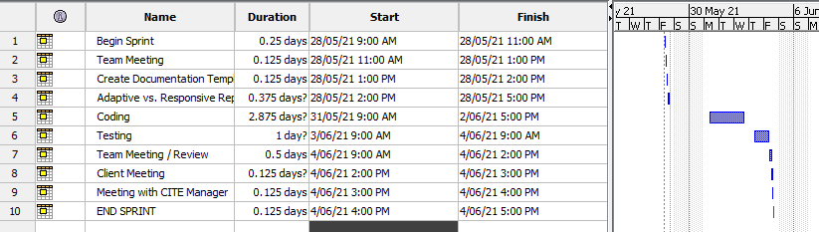

Figure - Project Management for sprint One

## Trello (Kanban Board)

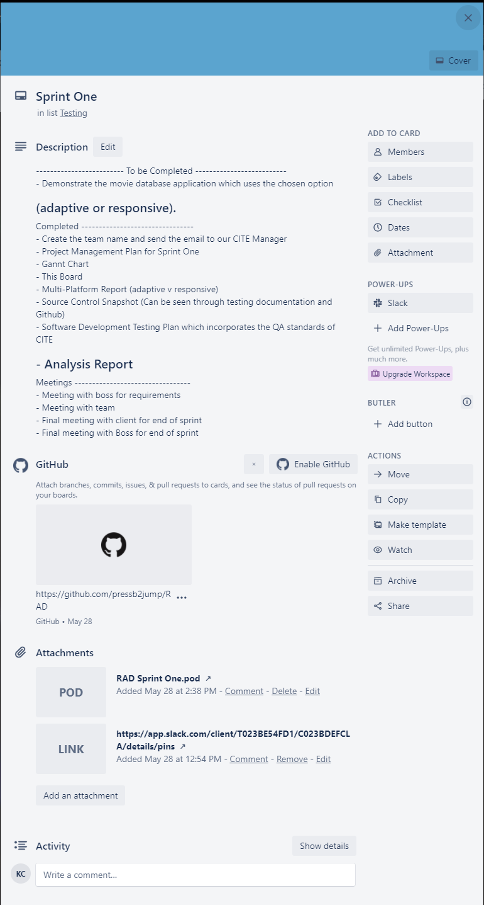This is the collaborative environment called Trello and includes all of the issues left to do.